Michigan History Nightmares
SCAVENGER HUNT
it’s fun to explore like Katie and her friends did as they followed the path along the St. Lawrence River that Father Marquette took in the early 1600s;
see how many of the same “treasures” you can find today…

THINGS TO GATHER AND COLLECT THINGS TO WITNESS AND VIEW
(3) different leaves butterfly
crooked stick worm
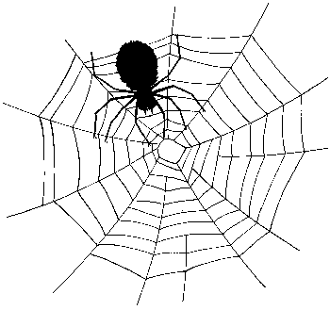
something that smells good spider web
acorn animal tracks
dandelion bee
pinecone chimney smoke
something that feels rough running water
tree bark squirrel
smooth rock red bird
plant root chalk markings
paper of any kind fruit/vegetable growing
white flower ants

